Steps to take Data Base back up
Step 1: Open Toad for MySQL Administrator
Step 2: Select “Backup” and select the Database
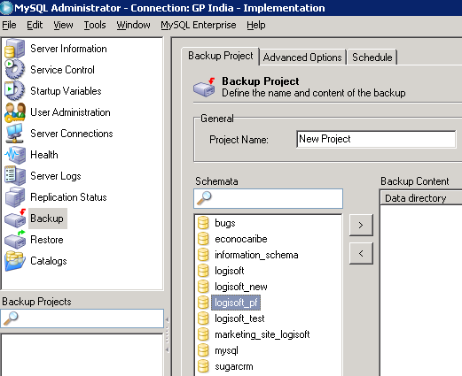

Step 3: Select Advance Options Tab and click “complete backup”
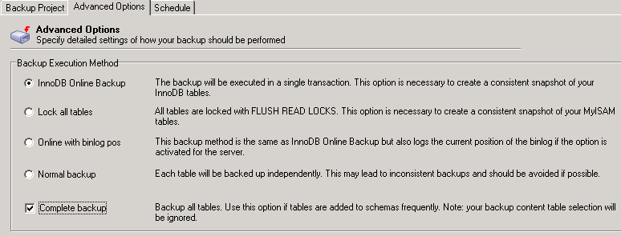

Step 4: Click “Execute Backup Now” and Specify the path and press OK


